2.50 Design a problem to help other students better understand wye-delta transformations using Fig. 2.114.

Although there is no correct way to work this problem, this is an example based on the same kind of problem asked in the third edition.

Problem

What value of R in the circuit of Fig. 2.114 would cause the current source to deliver 800 mW to the resistors.

Solution

Using 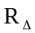 = 3R_{Y} = 3R, we obtain the equivalent circuit shown below:

30mA
3R
3R
3R
R
R
3R/2
30mA
3R

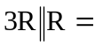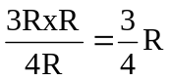

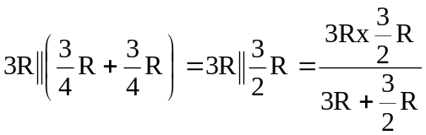= R

P = I²R 800 x 10⁻³ = (30 x 10⁻³)² R

R = 889 Ω

